**Standard Operating Procedure for Image at 00:56**

The following SOP is regarding the animation clip in the video “Understanding Brain Death English” on the ‘IGiftLife Foundation’ YouTube channel, and how to recreate that.

The clip consists of two ‘.PNG’ images of the brain and brain stem. Let us call them Brain_Image_1.png and Brain_Image_2.png.

These Images will be provided to you in a Google Drive link alongside the other material.

Brain_Image_1:

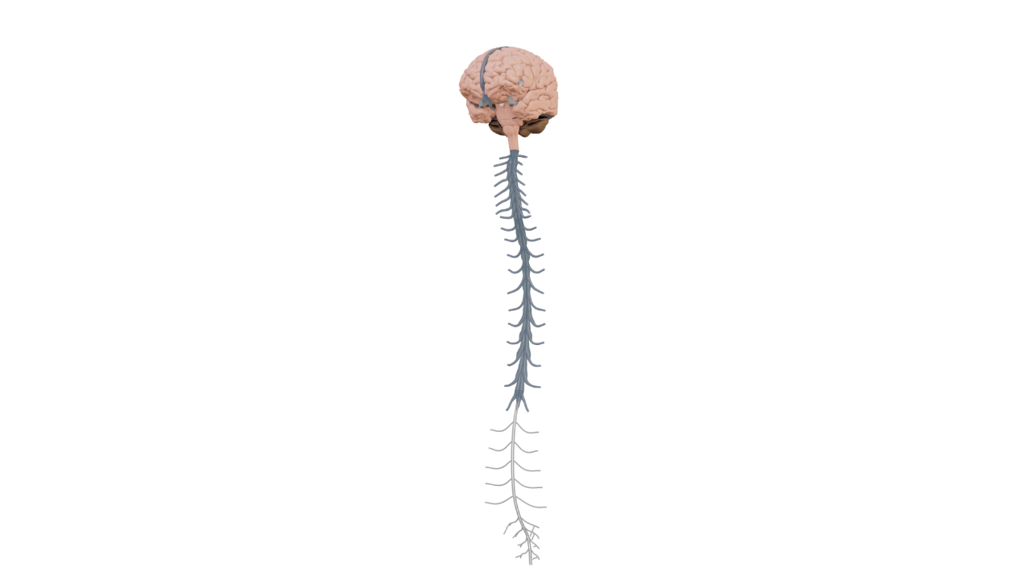Brain_Image_2:

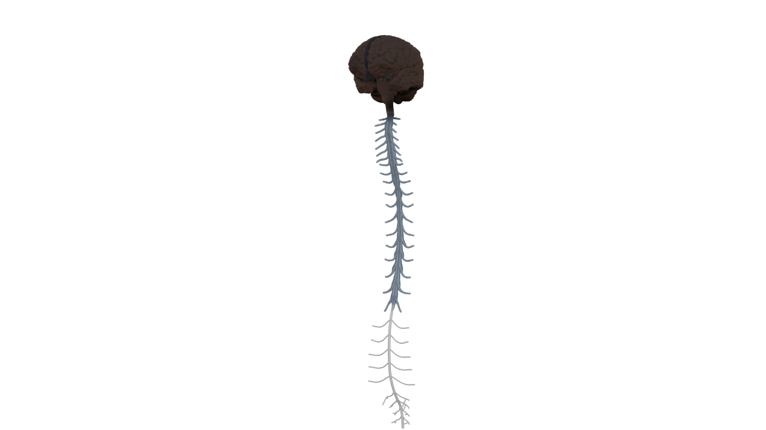

In order to recreate the animation from the YouTube clip at 00:56, the video editor needs to:

(Note: Add the 0100 - 0101 animation before Brain_Image_1.)

1. Import both the images into the editing software. (The editing software can be Camtasia, Davinci Resolve or Adobe Premiere Pro.)
2. The Editor needs to import the Brain_Image_1.png image at 00:56 into a layer/track in the timeline, and move it appropriately at the bottom right of the screen.
3. Then, at 01:01 the editor must import the Brain_Image_2.png in the timeline, in a new layer/track.
4. This image layer must be on top of the video layer playing in the background, as a result it will place the brain images on top of the screen.
5. Brain_Image_1.png has to be placed from 00:56 to 01:01, and at 01:01 Brain_Image_2.png has to be placed till 01:12.
6. In order to animate the movement at 01:01 like in the original video, the editor must add an inbuilt ‘Video Transition’ from inside the editing software. This is unique to whichever video editing software is being used, however it is very easy to find and use it in any editing interface.
7. The ‘Video Transition’ has to be placed in between the two images, and as a result the animation software will animate Brain_Image_1.png transitioning into Brain_Image_2.png. Video transitions are of many types, and it is upto the video editor to choose the appropriate video transition. However, it is recommended to use a ‘Fade Transition’ or a ‘Blur Transition’ to achieve the required effect.
8. In the event the editor is not able to find a ‘Video transition’ in the editing software, the editor must google the keywords “Video transition effects in [Editing Software Name].”

*Note:* For the rest please follow the timeline with respect to the original video (Understanding Brain Death English), for inserting the rest of the videos in the animation.

*Author’s Note:* In the event that the editor is unable to follow the steps mentioned in this document, the editor must apply for a video editing course on websites like Udemy or SkillShare. There are also free video editing basics and ‘masterclasses’ available on YouTube for various editing softwares, but it is recommended to go for a course on the mentioned websites. This is not a comprehensive Video Editing tutorial document; this is only a method to animate two .PNG images in transition.